ABOUT US

|  |  |  |  |
| --- | --- | --- | --- |
| **about**  **The SHIVAM EDUCATION POINT (P) Ltd**. has been established in the year 2012 with dynamic management with an **AIM TO MAKE MEDICAL EDUCATION TO OUR INDIAN STUDENTS** that to from middle class families. Who has an ambition and dreams to become a doctor. A sour quality of service idle help desk system to student with counselling organizing several educational seminars in with faculties and international educational managers from overseas, conduct interview and offer on the spot admissions to eligible candidates as per norms of Medical Council of India (MCI).  **SHIVAM EDUCATION POINT** is the direct admissions co-coordinating office of international university for entire India situated at RAJSTHAN , GUJARAT, HIMACHAL PRADESH , M.P ,A.P. This university has lowest fee package and better education standards for medical degree. We are giving more services at university campus and also we providing Indian food special INDIAN Mess with Indian chefs. We organizing visits in the hostel rooms every day, providing students progress and attendance data to the parents which can able the students time to time so that they will not diverse wide from education.  We are also providing and giving more consternation on medical council of India screening test coaching with well qualified and well experienced Indian FMG Professors at our campus. Which resulted, that university doctors has succeeded the MCI Test with at most success rate nearly 47% during September 2010 all these efforts are coming fruitful buyers with the heart full co-operation from our students and parents. We are also in process to create career opportunities to our doctors as soon as there come out from the university to be recruited at whereas corporate hospitals in INDIA.  The very authentic and specialized preparatory class of MCI Screening Test Modules from our Indian Students regularly for the last three consecutive years while study MBBS in college and this additional preparation make totally sure to the students to pass the test. Successfully and hold the practice of medicine in India apart from these we are also providing the various services.  **Our Mission** | | | |
| For those looking for hassle free process of getting foreign education, “SHIVAM EDUCATION POINT ” could be the directing force in providing full counselling support to the best of their satisfaction to help them reach the new height in their career through superior education | | | |
|  | | | |
| **Our Vision** | | | |
| To create an educational but communicative environment so that you always find exactly what you are looking for. “SHIVAM EDUCATION POINT” aspires to be a creating organization to all its constituents with a personal touch. | | | |
|  | | | |
| **FAQS** | | | |
|  | | | |
|  | | | |
| WHAT ARE THE DOCUMENTS REQUIRED? | | | |
| **Ans.** | The application should submit UC the following. | | |
|  | http://ismfocalpoint.com/images/sys3.gif | Application form filled | |
|  | http://ismfocalpoint.com/images/sys3.gif | Copy of secondary education certificate (10th & 12th certificate) | |
|  | s | Copy of birth certificate, copy of national passport | |
|  | | | |
| **How my parents will call me?** | | | |
| **Ans.** | Every Indian student is advised by SHIVAM EDUCATION POINT to have a mobile phone. Mobile phone system is highly developed in ABROAD and your parents can easily contact you. | | |
|  | | | |
| **If I need money in ABROAD , how my parents can send me money?** | | | |
| **Ans.** | The best way to transfer the money is to use international ATM/debit cards. For this purpose a student should open a bank account in India in a bank that is offering international ATM / debit card. Then, whenever he needs money, his parents will just deposit the required amount in this account and the student will withdraw the amount from any ATM machine of bank. Of course, rules and regulations of the banks will apply. For more details please contact your bank. | | |
|  | | | |
| **If I get ill in ABROAD , who will take care of me?** | | | |
| **Ans.** | First of all, SHIVAM EDUCATION POINT have organized a medical centre in the hostel itself. A Doctor is on duty in 24 hours a day. Every student should have compulsory medical insurance, which covers almost all bills of treatment. | | |
|  | | | |
| **Will I have an Internet facility?** | | | |
| **Ans.** | Yes, you will have the Internet facility with in hostel. | | |
|  | | | |
| **Can my parents visit me?** | | | |
| **Ans.** | Yes, your parents are most welcome to visit you and the academy. We even have a guest room in the hostel, where they can stay free of cost and if you are eating in the Indian mess, run by SHIVAM EDUCATION POINT, then your parents can dine with you free of cost during their stay. For details how they can get visa and for arrangement of their journey please contact office of SHIVAM EDUCATION POINT . | | |
|  | | | |
| **When are my vacations? Can I visit India during my vacations?** | | | |
| **Ans.** | Winter vacations are only 15 days in January, or February, but summer vacations are two months (July and August). You are advised to visit India during your summer vacation. SHIVAM EDUCATION POINT organize group journey for students to India helping them to acquire student's concession air tickets. | | |
|  | | | |
| **Is the hostel open during these vacations? Do I have to leave the hostel during the vacation?** | | | |
| **Ans.** | Yes, the hostel is open during vacations. No, you do not have to leave the hostel. You can stay at the hostel. | | |
|  | | | |
| **What I have to do at Airports during my first departure from India.** | | | |
| **Ans.** | Departure from Indira Gandhi International Airport New Delhi: | | |
|  | s | On entering the airport the first thing to do is to get your suitcase security checked on X-ray machine | |
|  | s | Wait for the announcement for check-in for your flight | |
|  | s | Find the check-in counter of your airline and go to the airline check-in counter. Get in the queue in front of the counter for your class of the ticket. When your turn comes, put your suitcase on the belt and give your air ticket. If you are a pure vegetarian then tell about this here on counter, but only if you have an air ticket with Vegetarian' stamp on it. Get your boarding card and air ticket. On boarding card there is following information: Your name, flight number, gate number and seat number | |
|  | s | Fill in the immigration form, which is available on the boarding counter. | |
|  | s | Proceed for the immigration counter and get in the queue for the Indians. | |
|  | s | When your turn comes, hand over your passport, Visa, Boarding card and filled up immigration form. Immigration officer will stamp the passport and will return these things. | |
|  | s | The next counter is for customs. Get yourself custom cleared and check your suitcase that it has passed the custom or not. Get your boarding card stamped by the custom officer. | |
|  | s | Go in the waiting hall and find the boarding gate number that is written on your boarding card. Wait till there is an announcement about your flight passengers to get your hand luggage and yourself checked by the security officers. | |
|  | s | Wait in the waiting hall till there is an announcement about your flight passengers to board the plane. Then proceed to the gate number for your flight, go to the plane through the tunnel, get in the plane and go to your seat, number of which is on your boarding card. Air hostess will help you in finding your seat | |
|  | | | |
| **Arrival at the abroad Airport:** | | | |
| **Ans.** | On arrival at the abroad airport, proceed to the immigration check with all passengers and get in the queue for foreigners, fill up the migration card available at the counters. When your turn comes, give your passport and visa. If immigration officer asks, then give him a copy of the invitation letter from the institute. He will stamp the passport and visa and will return you these things. | | |
|  | | | |
|  | Go to the luggage belts and find the belt with your flight number on it and wait for your suitcase and collect it. Fill up the custom clearance form available on counters and clearly write the amount of USA dollars, which you have with you. Proceed for the custom counter and put your luggage for custom check with your passport and the filled custom form. | | |
|  | | | |
| **Get out where a representative of UNIVERSITY is waiting for you.** | | | |
| **Ans.** | The Rules and Regulations for Residing in the Hostels of the UNIVERSITY The following rules and regulations for residing in the hostel (herein after hostel) of the UNIVERSITY have been made and approved under the signature and stamp of the Chancellor of UNIVERSITY and have received consent of shivam authority .The following rules and regulations for residing in the hostel of made for all foreign students who took admission through SHIVAM EDUCATION POINT | | |

|  |
| --- |
| **UNIVERSITY**  **Shota-Rustaveli-Batumi1.jpg**  **BATUMI SHOTA RUSTAVELI STATE UNIVERSITY**  **Introduction** |
| Batumi University is the oldest and most recognized university in the entire region having a state board of 125 years old history. In 2009 the LEPL Batumi Botanical Garden was joined to the University and Niko Berdgen ishvili Research Institute of Photo pathology were constituted. In 2011 a Scientific Centre was established comprising 5 faculties: Education and Sciences, Social Sciences, Business and Law, Agrarian Technologies an Ecology , Tourism and Engineering, Technologies. At present, about 5000 students study at the vocational, Bachelor, Master and Doctoral programs. At present Teaching and Research processes involve 244 professors, 55 researchers and 387 visiting professors. |
|  |
| The University actively engaged into directions of Natural sciences, Humanities, Social Sciences, Law, Mathematical and Computer Sciences, Engineering Technologies, Business and Public Health as well as Agricultural fields . Students studying here have opportunity to work as a junior resident doctor in pedagogical scientific activities and in Medical theory. |

|  |
| --- |
| **Education Base** |
| Shota Rostaveli University is oriented towards the demands of the society and the state.  Its first and foremost mission is: |
|  |
| To offer high quality education to all the interested people despite Nationality, religion and political status. To educate highly qualified, competitive and adaptive specialists to the changing professional environment, with the competencies relevant to the modern requirements, who will be the free personalities with high civic understanding and activity, bearers of the principles of humanism, democracy and liberal values. To accomplish fundamental and applied research in natural sciences, humanities, social sciences ,public health for the purpose of welfare of the population, economic strength, defence ability establishment of democratic principles and raising spirituality. |
| **Amenities** |
| University provides accommodation in hostels with all modern facilities. Hostels have access to internet services and students are protected by the Association of students. The mandatory requirement for staying in the hostel is strict maintenance of internal rules of the hostel. A laundry and press service also operates. Special workers have been appointed in order to maintain cleanliness in the hostel rooms, corridors, premises, toilets and bathrooms. |
|  |
| A group of Two or three students are allotted a room. This room is furnished with beds, side tables, chairs, one large sized study table, and a cupboard. Pillows, Bed Sheets, Mattresses, Quilts and Blankets are provided by the hostel in charge. Each room has a large window for easy ventilation. Every room has an automated heating device that runs 24x7 during the winter snow season to maintain optimum temperature in the hostel rooms. Each hostel floor has a set of toilets and bathrooms that have a regular 24x7 cold and hot water supply. |

|  |
| --- |
| **International Co-operation** |
| International Relations Department is a supporting structural unit of LEPL Batumi Shota Rustaveli State University. |
|  |
| The department deals with the establishment of relations with foreign universities and relevant scientific-research institutions and educational centres. It has to spread the information about the exchange programs and put them into practice. The Department is also in charge of the minutes (protocols); arrangement of hosting the delegations of foreign universities and organizations; development of collaboration with the higher educational institutions of the countries involved in Bologna Process; serving foreign students; supporting mobility process of students and other relevant services.  [**http://www.bsu.edu.ge/?lang=en**](http://www.bsu.edu.ge/?lang=en) |
| **Photo gallery** |

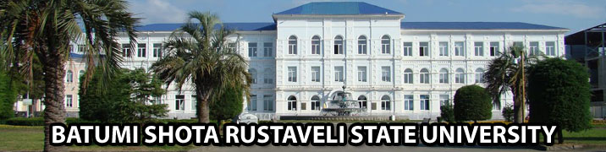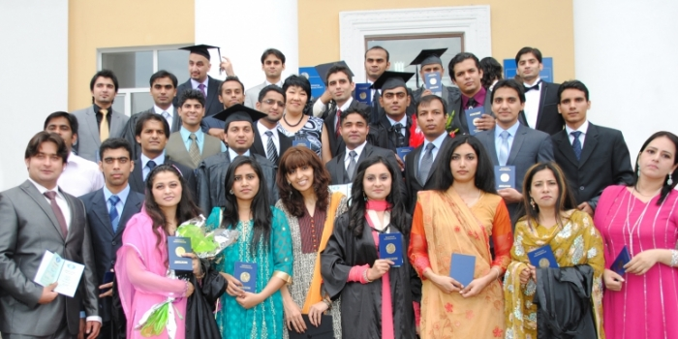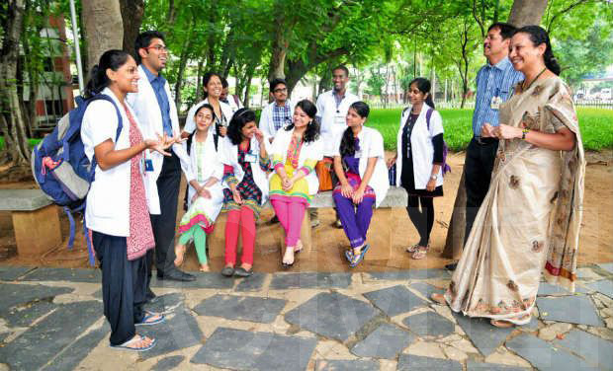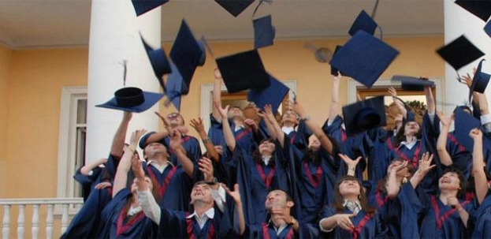

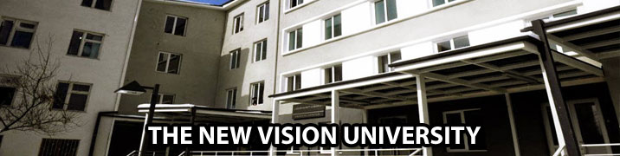

**NEW VISION UNIVERSITY**

|  |  |
| --- | --- |
| **Introduction** | |
| The New Vision University is a Autonomous non profit research University, aiming at expanding human vision it is affiliated to the 75 years old Tbilisi state Medical University, Georgia, Managed by Ministry of Health. | |
|  | |
| NVU is associated with GEO Group of Hospitals in Tbilisi itself to conduct medical training and practices. | |
|  | |
| NVU as a college which deals with establishment of relations with foreign universities, relevant Scientific research institute and Educational centres. | |
|  | |
| Faculty of NVU participates in Scientific conferences and exchange program in different countries like USA, UK and European countries. NVU is ranked in the top Universities imparting Medical all across Euroasia. | |
| **Education Base** | | |
| The New Vision University is a Autonomous non profit institution aiming at expanding human vision through introducing new approaches in the field of education, research and innovation. | | |
|  | | |
| A number of scientific-research projects of international and national significance have been accomplished on the university base. The university has close partnership relations with the leading higher educational institutions within and outside the country like in UK Leeds University England. NVU is considered a desirable host for international scientific conferences and symposia held in various fields of science. Apart from this, the academic and scientific faculty of the university actively participates in scientific conferences and exchange programs in different countries of the world Like USA, UK and Other European Countries. | | |
|  | | |
| NVU is oriented towards the demands of the society and the state. Its and foremost mission is: | | |
|  | | |
| 1. To offer high quality education to all the interested people despite Nationality, religion and political status. | | |
| 2. To educate high-qualified, competitive and adaptive specialists to changing professional environment, with the competencies relevant to the modern requirements, who will be the free personalities with high civic understanding and activity, bearers of the principles of humanism, democracy and liberal values. | | |
|  | | |
| **The main goals of the NVU shall be:** | | |
|  | Offering the educational programs promoting the free development of an individual: “A student creates his/her own profile”: The educational programs are oriented on the free choice of a student to develop the desirable competencies in the major field of study and acquire an additional specialty or arrange for free concentration of the components of various programs; | |
|  |  | |
|  | Promotion of the establishment of the standards of academic integrity, encouragement of the research activities of the NVU academic personnel and integration of students into this process. | |
|  |  | |
|  | Development of the various models of introduction of novelties. | |
|  | | |
| Amenities | | |
| New Vision Foreign students are offered a room in the hostel. This room is furnished with beds, side tables, chairs, one large sized study table, and a cupboard. Pillows, Bed Sheets, Mattresses, Quilts and Blankets are provided by the hostel in charge. Each room has a large window for easy ventilation. Every room has an automated heating device(Room warmers) that runs 24x7 during the winter snow season to maintain optimum temperature in the hostel rooms. Each hostel floor has a set of toilets and bathrooms that have a regular 24x7 cold and hot water supply | | |
|  | | |
| Mess: Food is the most important and the basic necessity of life. Keeping this necessity in mind, NVU has a special provision for food and catering to student needs through its mess/canteen. The university's hostel has a canteen where Asian cooks work. Students have opportunities to enjoy the traditional Indian cuisine. However currently, the mess operates for foreign students only. The Indian NVU mess has a variety of menu that includes chapati, rice, sweets etc. The NVU Mess serves Vegetarian and Non Vegetarian dishes. Vegetarian dishes include vegetables and pulses while Non Vegetarian dishes include mutton, chicken and fish. Meals are served three times a day. Special preparations can be ordered or requested by students to the NVU mess administration to celebrate birthdays, festivals and parties etc. | | |
|  |  | |
| **International Co-operation** | | |
| New Vision University participated in an International Education Fair that took place in Tbilisi on February 2015. International Education Fair is an annual event, with the participation of a number of universities, colleges, business schools and educational organizations from Georgia, UK, India ,Turkey, Italy, Latvia, Lithuania, Poland, etc. | | |
|  | | |
| Representatives of the New Vision University answered the questions of the prospective students concerning the Programs offered by NVU, including the new program in Politics and Diplomacy , that will be launched in 2015, Fall semester.  **http://newvisionuniversity.net/** | | |

**Photo gallery**

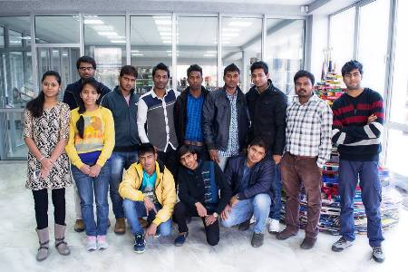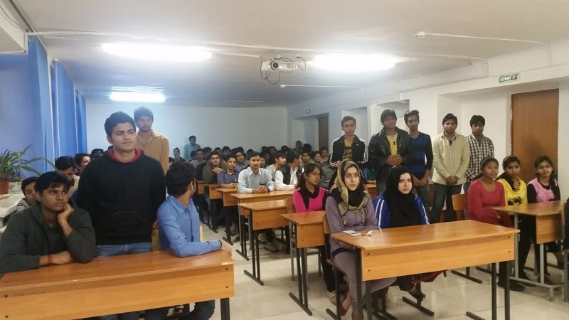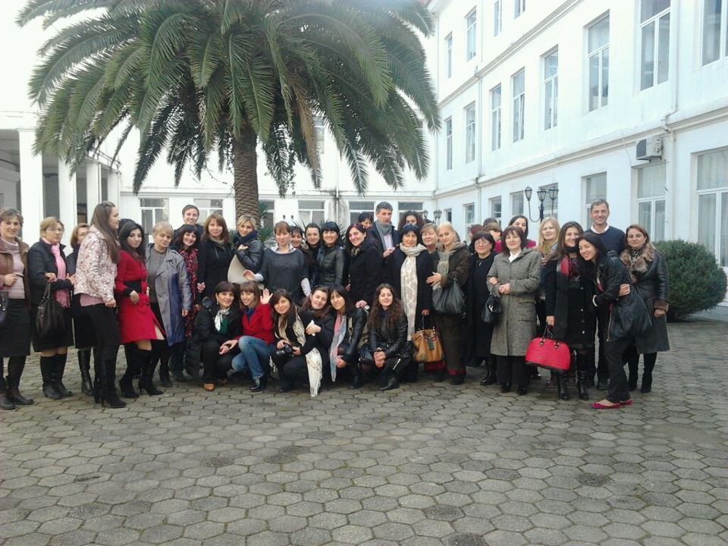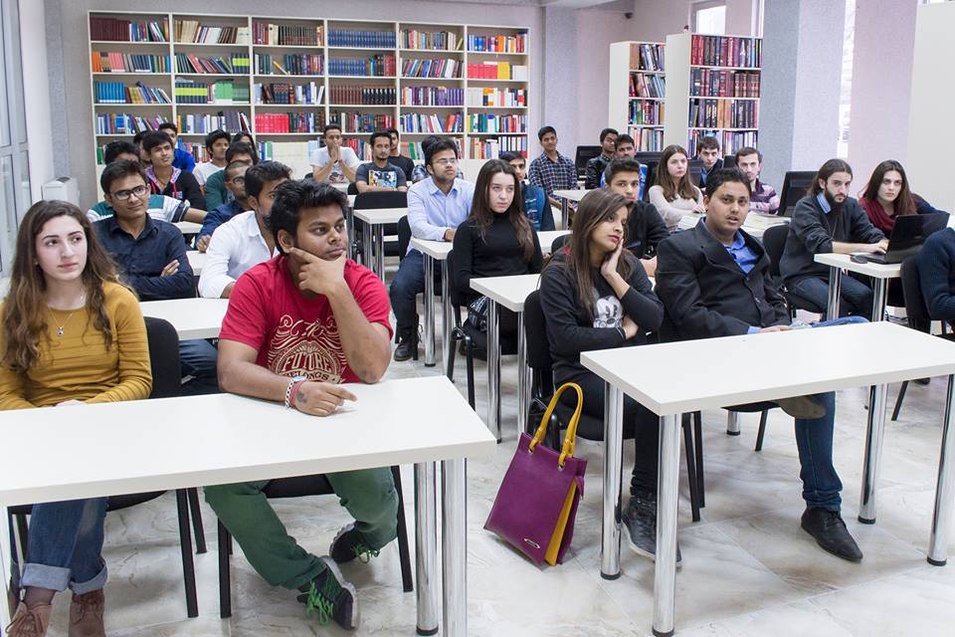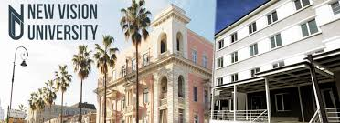

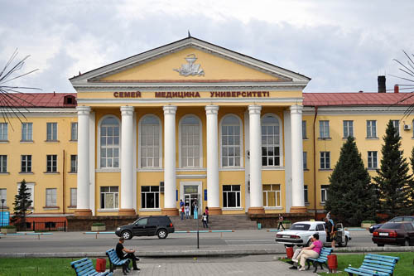

**Semey state medical university**

**Introduction**

Semey State Medical University – was founded as “Semipalatinsk State Medical Institute” by the order (order No. 22611-P, dated 2 September 1952) of the USSR Board of ministers and the USSR Ministry of Health Services in 1952. By the order (order No. 20-L, dated March 03-1997) of the Health Services Committee of the Republic of Kazakhstan, it was transformed into “Semipaltinsk Government (State) Medical Academy” in 1997 and by the SGMAa Resolution of the Parliament of the Republic of Kazakhstan ¹ 188, dated 19th of February 2009, the Academy was renamed as “Semey State Medical University- The university during the period of its existence for more than 55 years have prepared more than thirty five thousand highly qualified doctors- specialists, who offer their services not only in Kazakhstan and CIS countries, but in the foreign countries like USA, Germany, Australia, India, Pakistan, Israel & many other countries and wherever they may not work, they introduce themselves as the graduates from the university with great pride.

**Education base**

|  |
| --- |
| Semey state University is oriented towards the demands of the society and the state . Its first and foremost mission is: |
|  |
| To offer high quality education to all the interested people despite Nationality, religion and political status. To educate highly qualified, competitive and adaptive specialists to the changing professional environment, with the competencies relevant to the modern requirements, who will be the free personalities with high civic understanding and activity, bearers of the principles of humanism, democracy and liberal values. To accomplish fundamental and applied research in natural sciences, humanities, social sciences ,public health for the purpose of welfare of the population, economic strength, defence ability establishment of democratic principles and raising spirituality.  **amenities** |

|  |
| --- |
| University provides accommodation in hostels with all modern facilities. Hostels have access to internet services and students are protected by the Association of students. The mandatory requirement for staying in the hostel is strict maintenance of internal rules of the hostel. A laundry and press service also operates. Special workers have been appointed in order to maintain cleanliness in the hostel rooms, corridors, premises, toilets and bathrooms. |
|  |
| A group of Two or three students are allotted a room. This room is furnished with beds, side tables, chairs, one large sized study table, and a cupboard. Pillows, Bed Sheets, Mattresses, Quilts and Blankets are provided by the hostel in charge. Each room has a large window for easy ventilation. Every room has an automated heating device that runs 24x7 during the winter snow season to maintain optimum temperature in the hostel rooms. Each hostel floor has a set of toilets and bathrooms that have a regular 24x7 cold and hot water supply. |

**International co – operation**

|  |
| --- |
| International Relations Department is a supporting structural unit of semey state medical University. |
|  |
| The department deals with the establishment of relations with foreign universities and relevant scientific-research institutions and educational centres. It has to spread the information about the exchange programs and put them into practice. The Department is also in charge of the minutes (protocols); arrangement of hosting the delegations of foreign universities and organizations; development of collaboration with the higher educational institutions of the countries involved in Bologna Process; serving foreign students; supporting mobility process of students and other relevant services.  [**http://www.ssmu.kz/site/index?lang=en**](http://www.ssmu.kz/site/index?lang=en) |

**Photo gallery**

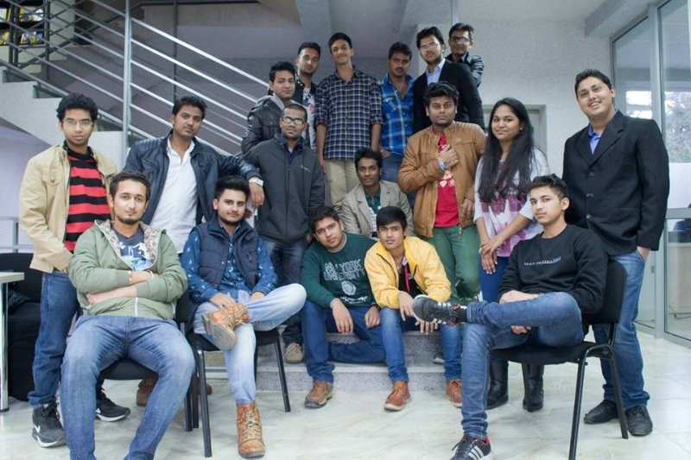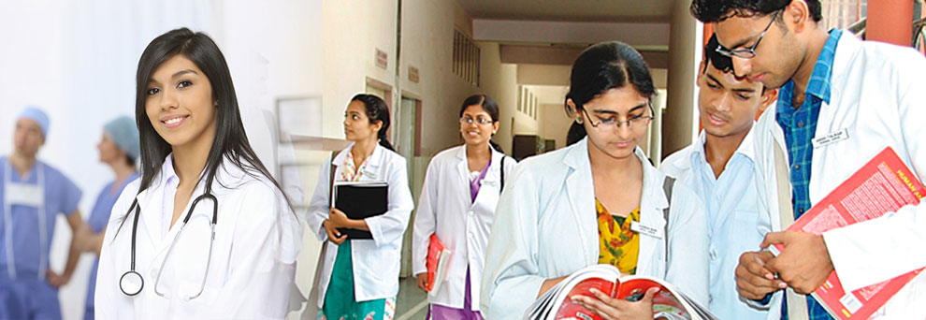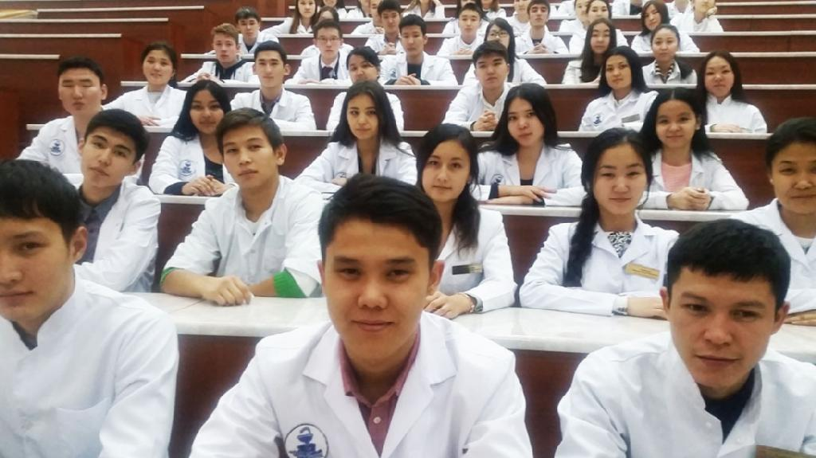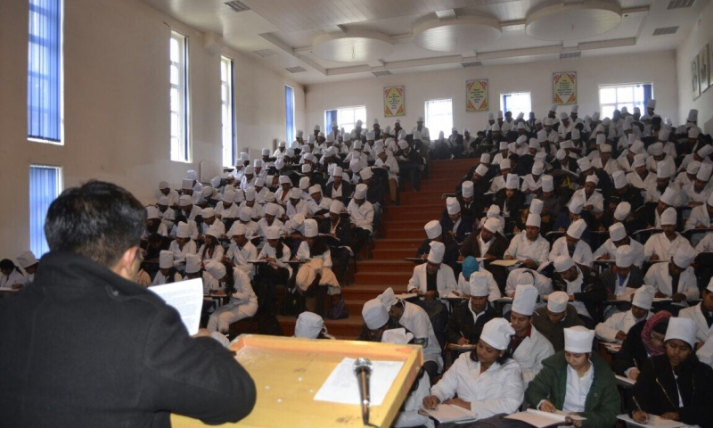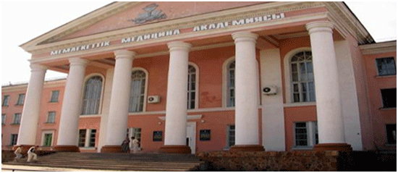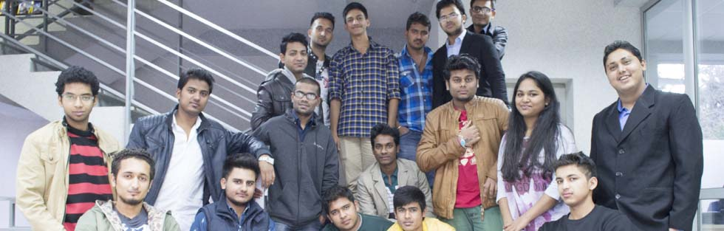

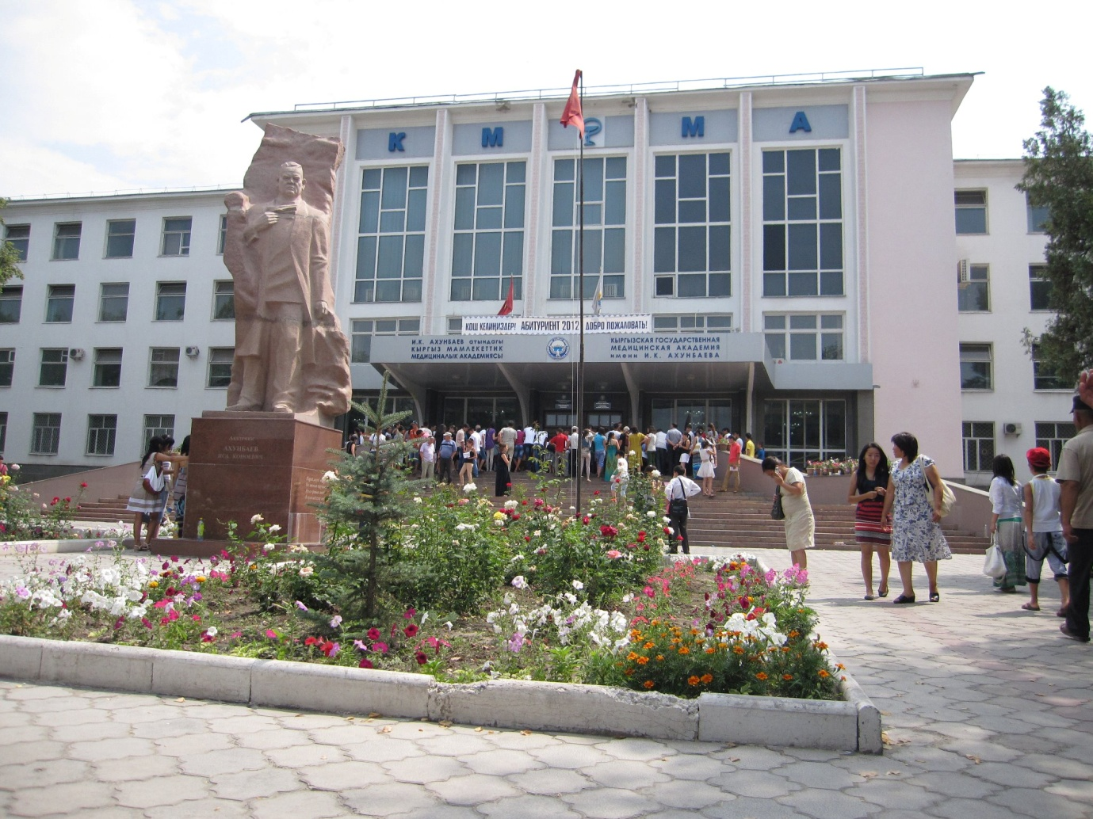**kyrgyz state medical academy**

**Introduction**

The **Kyrgyz State Medical Institute (KSMA)** was opened on 1 September 1939 in the city of [Bishkek](https://en.wikipedia.org/wiki/Bishkek) (formerly Frunze),[Kyrgyzstan](https://en.wikipedia.org/wiki/Kyrgyzstan" \o "Kyrgyzstan), with the recruitment of 200 students. The establishment of the institute was contributed to by the First Moscow Medical Institute, high [medical schools](https://en.wikipedia.org/wiki/Medical_school) of [Saint-Petersburg](https://en.wikipedia.org/wiki/Saint_Petersburg), Almaty , Tashkent and other medical institutions. They provided expertise and organizational assistance, medical guidelines and training books as well as faculty staff.

**Education base**

|  |
| --- |
| Ksma is oriented towards the demands of the society and the state . |
|  |
| high quality education to all the interested people despite Nationality, religion and political status. To educate highly qualified, competitive and adaptive specialists to the changing professional environment, with the competencies relevant to the modern requirements, who will be the free personalities with high civic understanding and activity, bearers of the principles of humanism, democracy and liberal values. To accomplish fundamental and applied research in natural sciences, humanities, social sciences ,public health for the purpose of welfare of the population, economic strength, defence ability establishment of democratic principles and raising spirituality.  **amenities** |
| University provides accommodation in hostels with all modern facilities. Hostels have access to internet services and students are protected by the Association of students. The mandatory requirement for staying in the hostel is strict maintenance of internal rules of the hostel. A laundry and press service also operates. Special workers have been appointed in order to maintain cleanliness in the hostel rooms, corridors, premises, toilets and bathrooms. |
|  |
| A group of Two or three students are allotted a room. This room is furnished with beds, side tables, chairs, one large sized study table, and a cupboard. Pillows, Bed Sheets, Mattresses, Quilts and Blankets are provided by the hostel in charge. Each room has a large window for easy ventilation. Every room has an automated heating device that runs 24x7 during the winter snow season to maintain optimum temperature in the hostel rooms. Each hostel floor has a set of toilets and bathrooms that have a regular 24x7 cold and hot water supply. |

International co – operation

Basic goals of the partnership are:

* Training of teachers and development of educational programs for managers in the public health system, policymakers in public health system and practitioners, family physicians and nurses with [higher education](https://en.wikipedia.org/wiki/Higher_education) degree.
* Implementation of two modelling family clinics (one city, another rural) that will form educational base for the КSМА and its curricula. Creation of conditions for programs implementation of healthy communities on sites of service of two modelling clinics.
* Implementation on the clinical bases of clinical and administrative reports and programs, and also modelling strategy on strengthening health and diseases' prevention.

Under the partnership cooperation was launched between the КSМА and [University of South Florida](https://en.wikipedia.org/wiki/University_of_South_Florida) in the field of Public Health.

There is cooperation between the КSМА and the Clinic of Manual, Plastic and [Reconstructive Surgery](https://en.wikipedia.org/wiki/Reconstructive_surgery) of the [Zurich University](https://en.wikipedia.org/wiki/University_of_Zurich) with joint scientific and clinical researches, an exchange of experts, organization of joint discussions, international conferences and training.

The Plastination Centre in the academy was established under cooperation with the Institute of Plastination of the [Heidelberg University](https://en.wikipedia.org/wiki/Ruprecht_Karl_University_of_Heidelberg) (Germany). КSМА has a museum of [plastination](https://en.wikipedia.org/wiki/Plastination).

The Medical Academy has signed agreements of cooperation with Mudonzjan Medical Institute (the People's Republic of China), with [Novosibirsk State Medical Academy](https://en.wikipedia.org/wiki/Novosibirsk_State_Medical_Academy)(Russia), with Turkmen State Medical Institute (Turkmenistan) and with the second Tashkent State Medical Institute (Uzbekistan).

[**http://ksma.yolasite.com/**](http://ksma.yolasite.com/)

**Photo gallery**

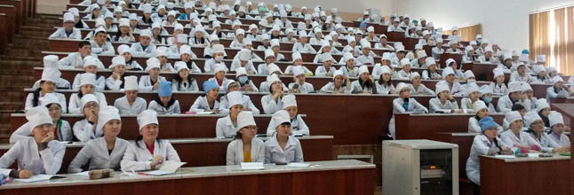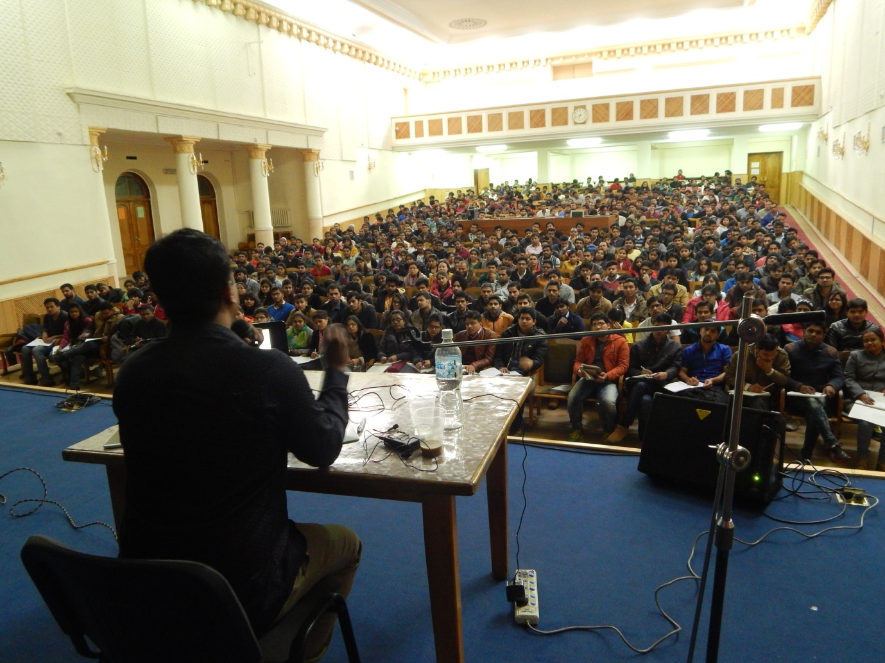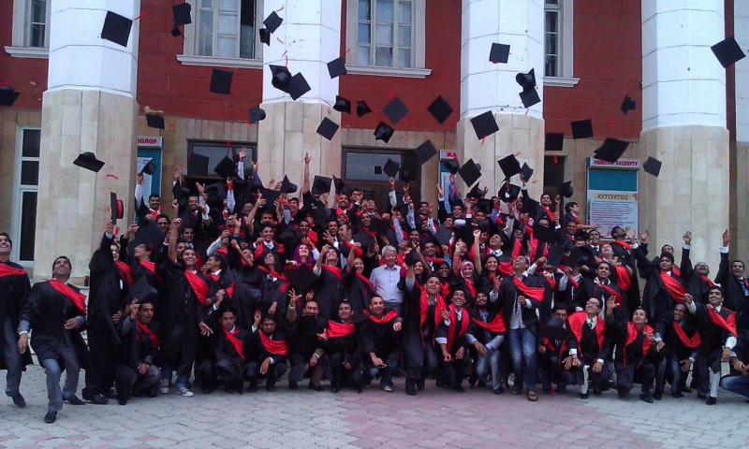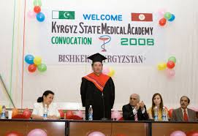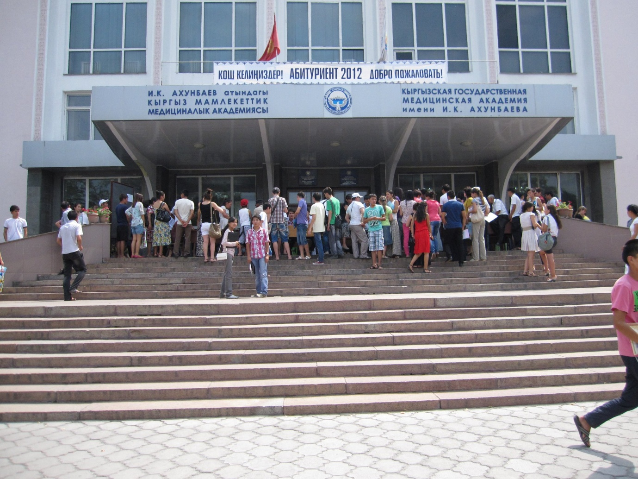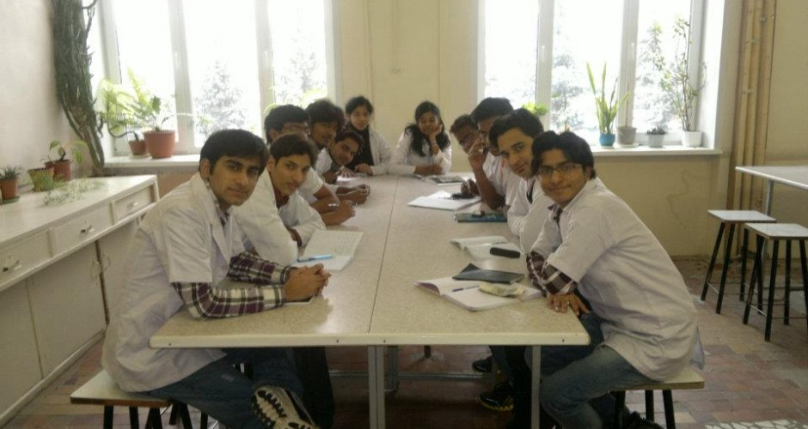

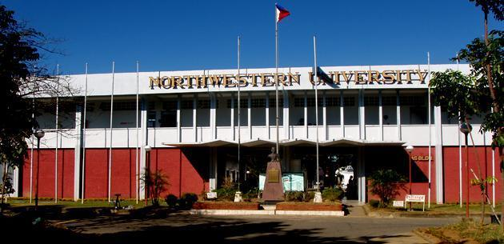

**Lyceum northwestern university**

**Introduction**

The Lyceum-Northwestern University believes that the moral obligation of any institution of learning is to prepare the students into productive professionals and entrepreneurs equipped with the educational modernity, social and spiritual values to face the dynamism

Quimson Duque and Mrs. Florencia Tiongson Duque in 1969.

Lyceum-Northwestern University though bearing the word [Lyceum](https://en.wikipedia.org/wiki/Lyceum) is not affiliated with [Lyceum of the Philippines University](https://en.wikipedia.org/wiki/Lyceum_of_the_Philippines_University) since LPU is the first and original institution in the country to bear the word [Lyceum](https://en.wikipedia.org/wiki/Lyceum).

**Education base**

|  |
| --- |
| Lnu is oriented towards the demands of the society and the state . |
|  |
| high quality education to all the interested people despite Nationality, religion and political status. To educate highly qualified, competitive and adaptive specialists to the changing professional environment, with the competencies relevant to the modern requirements, who will be the free personalities with high civic understanding and activity, bearers of the principles of humanism, democracy and liberal values. To accomplish fundamental and applied research in natural sciences, humanities, social sciences ,public health for the purpose of welfare of the population, economic strength, defence ability establishment of democratic principles and raising spirituality.  **amenities** |
| University provides accommodation in hostels with all modern facilities. Hostels have access to internet services and students are protected by the Association of students. The mandatory requirement for staying in the hostel is strict maintenance of internal rules of the hostel. A laundry and press service also operates. Special workers have been appointed in order to maintain cleanliness in the hostel rooms, corridors, premises, toilets and bathrooms. |
|  |
| A group of Two or three students are allotted a room. This room is furnished with beds, side tables, chairs, one large sized study table, and a cupboard. Pillows, Bed Sheets, Mattresses, Quilts and Blankets are provided by the hostel in charge. Each room has a large window for easy ventilation. Every room has an automated heating device that runs 24x7 during the winter snow season to maintain optimum temperature in the hostel rooms. Each hostel floor has a set of toilets and bathrooms that have a regular 24x7 cold and hot water supply. |

**International co- operation**

|  |
| --- |
| International Relations Department is a supporting structural unit of lyceum north western university . |
|  |
| The department deals with the establishment of relations with foreign universities and relevant scientific-research institutions and educational centres. It has to spread the information about the exchange programs and put them into practice. The Department is also in charge of the minutes (protocols); arrangement of hosting the delegations of foreign universities and organizations; development of collaboration with the higher educational institutions of the countries involved in Bologna Process; serving foreign students; supporting mobility process of students and other relevant services.  [**http://lyceum.edu.ph/**](http://lyceum.edu.ph/) |

**Photo gallery**

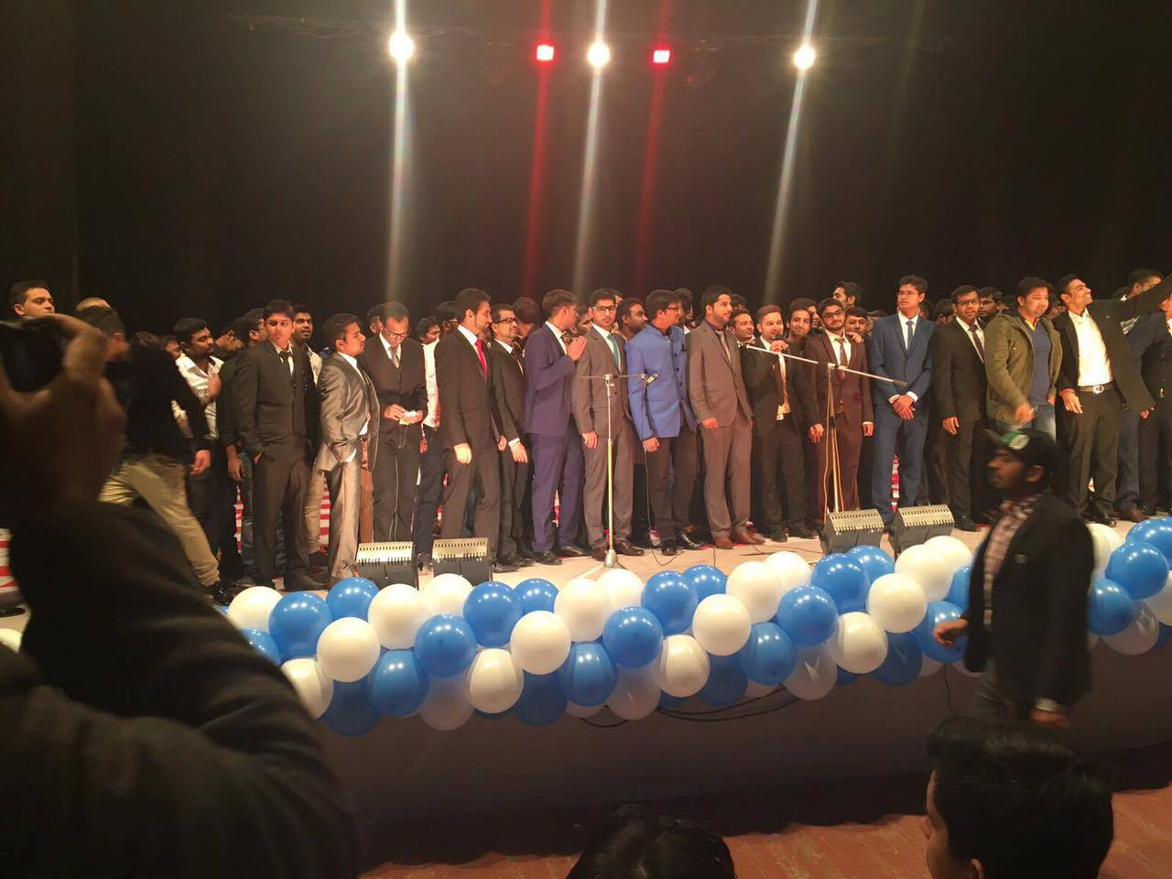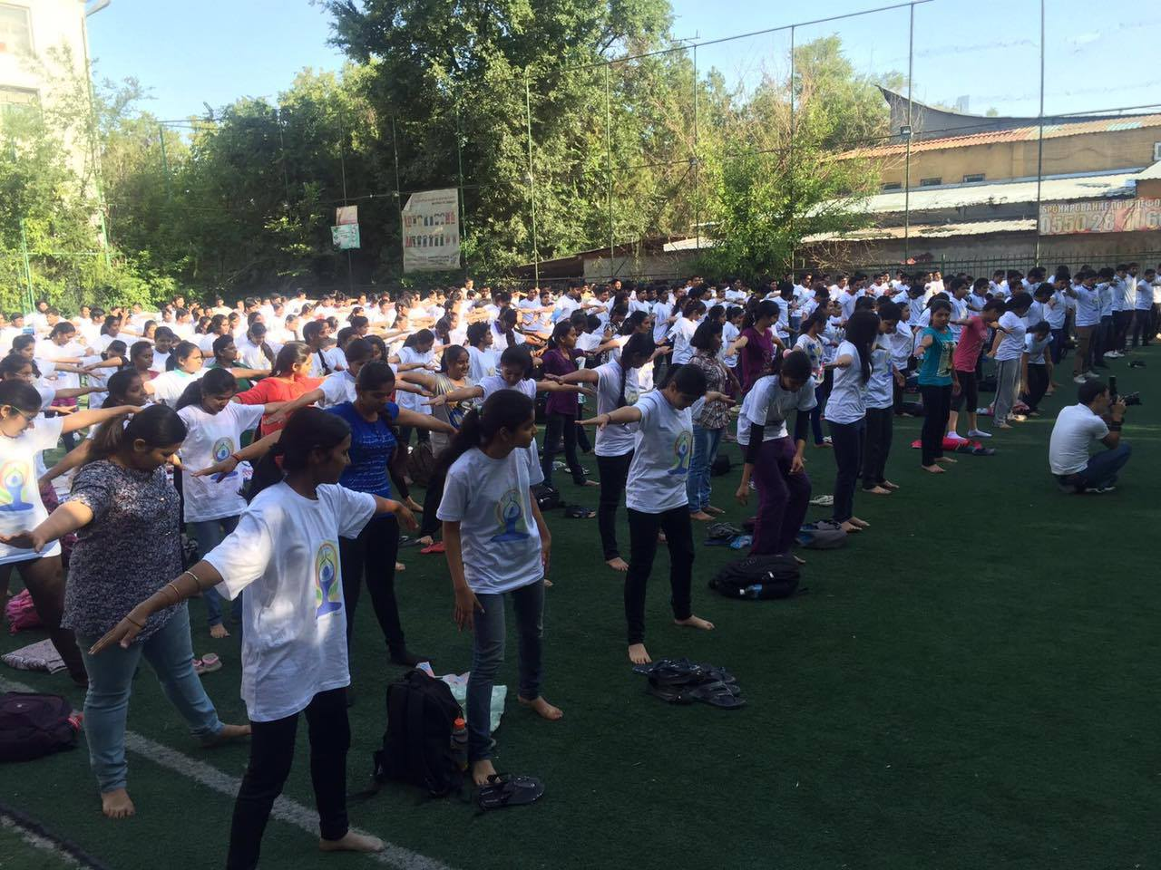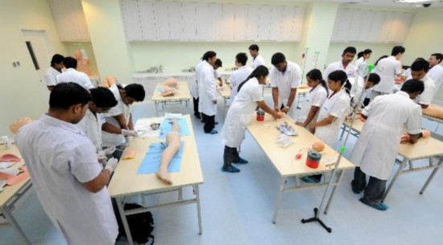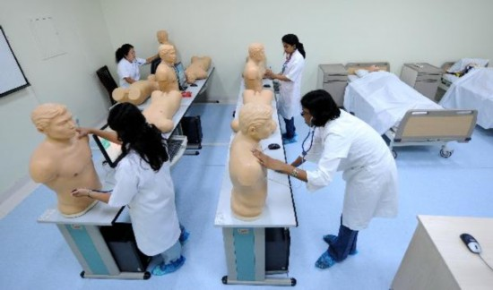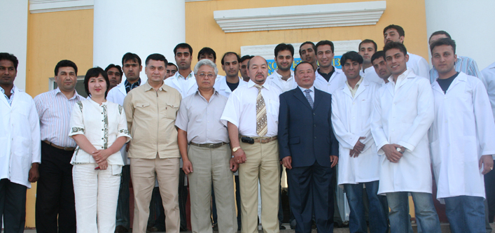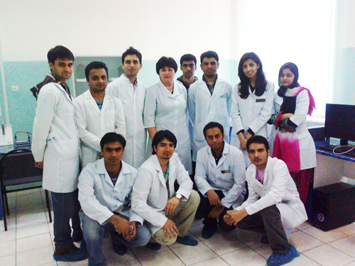

|  |  |  |
| --- | --- | --- |
| **Services** | | |
| SHIVAM EDUCATION POINT is leading and fastest developing global education consultants, SHIVAM EDUCATION POINT is specialized in offering the most competitive and trustworthy services to the aspiring students aspiring to study ABROAD  . | | |
|  | | |
|  | **Our Services** | |
|  | http://ismfocalpoint.com/images/sys_1.gif | Providing University Information |
|  | http://ismfocalpoint.com/images/sys_1.gif | Complete Admission Process (Admission Letter, Students Visa) |
|  | http://ismfocalpoint.com/images/sys_1.gif | Assistance on preparation of Physical Examination From on request |
|  | http://ismfocalpoint.com/images/sys_1.gif | Filing of students visa application to Embassy |
|  | http://ismfocalpoint.com/images/sys_1.gif | Assistance to filling MCI eligibility Certificate |
|  | http://ismfocalpoint.com/images/sys_1.gif | Obtain confirmation letter from the college |
|  | http://ismfocalpoint.com/images/sys_1.gif | Arrange for travel and stay abroad |
|  | http://ismfocalpoint.com/images/sys_1.gif | Provide orientation programs |
|  | http://ismfocalpoint.com/images/sys_1.gif | Complete guidance in preparation of admission and visa documentation |
|  | http://ismfocalpoint.com/images/sys_1.gif | Assistance in discounted air tickets |
|  | http://ismfocalpoint.com/images/sys_1.gif | Complete guidance from home land to university |
|  | http://ismfocalpoint.com/images/sys_1.gif | Assistance/ guidance opening in bank account near to university |
|  | http://ismfocalpoint.com/images/sys_1.gif | Assistance/ guidance from airport to university |
|  | http://ismfocalpoint.com/images/sys_1.gif | Assistance /travel from and to university up to INDIA during the vacations. |
|  | http://ismfocalpoint.com/images/sys_1.gif | Providing MCI Screening Test Coaching at University campus with well experienced Indian FMGE Professors |
|  | | |
| **VISA DOCUMENTATION** | | |
| SHIVAM EDUCATION POINT provides excellent visa documentation for student visa, when a candidate applies for a student visa he/she requires certain documents which has to be presented at the consulate, SHIVAM EDUCATION POINT helps the students to prepare all the required documents. | | |
|  | | |
| **APPLICATION FORMS** | | |
| SHIVAM EDUCATION POINT helps by providing all the application forms, which are required and will be filled with our supervision | | |
|  | | |
| **Travel Arrangements & Forex** | | |
| SHIVAM EDUCATION POINT will help in providing Air tickets with discounted rates to students when there is a peek session of students going to study abroad. Ensuring the safety and security of all candidates by recruiting SHIVAM EDUCATION POINT personnel to coordinate the process from admission to travel ABROAD | | |

**MIST**

|  |
| --- |
| "MIST is the only one of its kind institute which has been specially designed for the changing trends and pattern required from a international medical graduate in achieving his dream come true without wasting his precious time and money. " |
|  |
| MIST is a cohesive work force of leading educationists having a vast experience in teaching international and national medical graduates. The teaching faculties and the management at Mist comprises of individuals who have themselves experienced and mingled with the students in their respective countries. After a live experience with the students in their hostel, college, kitchen and the environment, we have analysed the hardships of the students which they have faced outside India. At a tender age of 18, the Indian petals have started adapting to conditions where they have to learn a different language, different pattern of teaching, cook for themselves, lead a responsible social life and above all have a humane attitude towards life. Believe it or not, we have drawn a conclusion that these petals become blossoming flowers when they come back to India. We strongly believe the personality of these students is much superior to many of those completing their education in India itself. With such a strong belief, further what is required is the right guidance and approach in clearing the screening test which is what we are committed to provide, and it does not end here….**OUR AIM IS TO ACHIEVE A QUALITY LIVING AND A BECOME A BETTER HUMAN BEING EVEN AFTER CLEARING THE 1st STEP IN INDIA.“BE POSITIVE ALWAYS— AND BEFORE SAYING NO, SAY I WILL TRY AND THEN GIVE IT YOUR BEST”** |
|  |
| **Admission Requirement** | **http://www.ismiuk.com/images/arrow.gif** |
| |  |  | | --- | --- | |  | | | **Necessary Condition** | | |  | | | http://www.ismiuk.com/images/sys4.gif | completed intermediate education, equivalent to secondary education of the UNIVERSITY | | http://www.ismiuk.com/images/sys4.gif | 50% rating scores | | http://www.ismiuk.com/images/sys4.gif | Admission fee (is not returned on violation) | |  | Paying capacity | | Admission | Requirement | | **Necessary documents (originals)** | | | http://www.ismiuk.com/images/sys4.gif | Certificate of completed intermediate education | | http://www.ismiuk.com/images/sys4.gif | Reference of Ministry of Education of the UNIVERSITY on equivalency to secondary education of  the UNIVERSITY | | http://www.ismiuk.com/images/sys4.gif | Passport with appropriate entry visa | | http://www.ismiuk.com/images/sys4.gif | Medical reference – 086 form, (medical inspection can be provided in the Medical Centre ) | | http://www.ismiuk.com/images/sys4.gif | 8 photos (3x4) | |  |  | | **Necessary documents when being transferred from other Higher Medical Institution** | | | http://www.ismiuk.com/images/sys4.gif | Certificate of completed intermediate education | | http://www.ismiuk.com/images/sys4.gif | Reference of Ministry of education of the UNIVERSITY on equivalency to secondary education of the UNIVERSITY | | http://www.ismiuk.com/images/sys4.gif | Academic reference from previous Higher Medical Institution | | http://www.ismiuk.com/images/sys4.gif | Certificate of Preparatory department | | http://www.ismiuk.com/images/sys4.gif | Passport, with appropriate entry visa | | http://www.ismiuk.com/images/sys4.gif | Medical reference-086 form (medical inspection can be provided in the Medical Centre ) | | http://www.ismiuk.com/images/sys4.gif | 8 photographs (3x4) |   How to apply  First STEP –   1. Required document for admission 2. Std. 10th mark sheet with certificate 3. Std .11th  mark sheet 4. Std . 12th mark sheet with certificate   Second STEP –   1. Required document for passport  * Birth certificate * Voter id * Residence proof * Photo colour 8 passport size   THIRD STEP –   1. Medical report 2. All document legalization and translate from **HRD & embassy** 3. Invitation 4. Visa 5. Air ticket 6. Miscellaneous expenses ( only for the first year ) university fees   FORTH STEP –   * After you have arrived at abroad airport and university * Your passport shall be registered by ministry of interior of that country embassy within 5 days from the date of arrival, * Excluding holidays and weekends * Assistance in registration and visa extension will be provided foreign student must get registered between 6 month and 1 year * Passport must be presented to the department of international affairs, 1 month before the expiration of visa * Failure to meet registration and visa terms results in fine, set by ministry of interior of that country   **DEADLINE FOR ADMISSION OF INTERNATIONAL STUDENTS DEPENDS ON THE SELECTED PROGRAM**   * Fall semester – until 5th September     **THE ADDITIONAL CHARGES OF INVITION, VISA , ETC. ARE PAYABLE AT THE TIME OF ADMISSION . THE DETAILS ARE AVAILABLE WITH OUR INDIAN ASSOSIATES .** |  |

Contacts

JAIPUR BRANCH:-

SHIVAM EDUCATION POINT

CONTACT :- MR. ASHOK KUMAR SHARMA

ADDRESS :- C 36 ANAJ MANDI VKI AREA 12 , JAIPUR

MOB :- +918560961337

JODHPUR BRANCH :-

SHIVAM EDUCATION POINT

CONTACT:- MR.SURENDRA & MR NAVATEJ CHOUDHARY

ADDRESS:-NEAR SHIV MANDIR RATANDA , JODHPUR

MOB:- +917073400555,+919462616105

**Email :-**[**shivameducationpoint@gmail.com**](mailto:shivameducationpoint@gmail.com)

**Yahoo :- educationpointshivam@yahoo.com**

**Website:-**[**https://www.shivameducationpint.com/**](https://www.shivameducationpint.com/)